**Image processing HW4 Name:武敬祥 ID:b06611032**

# GUI

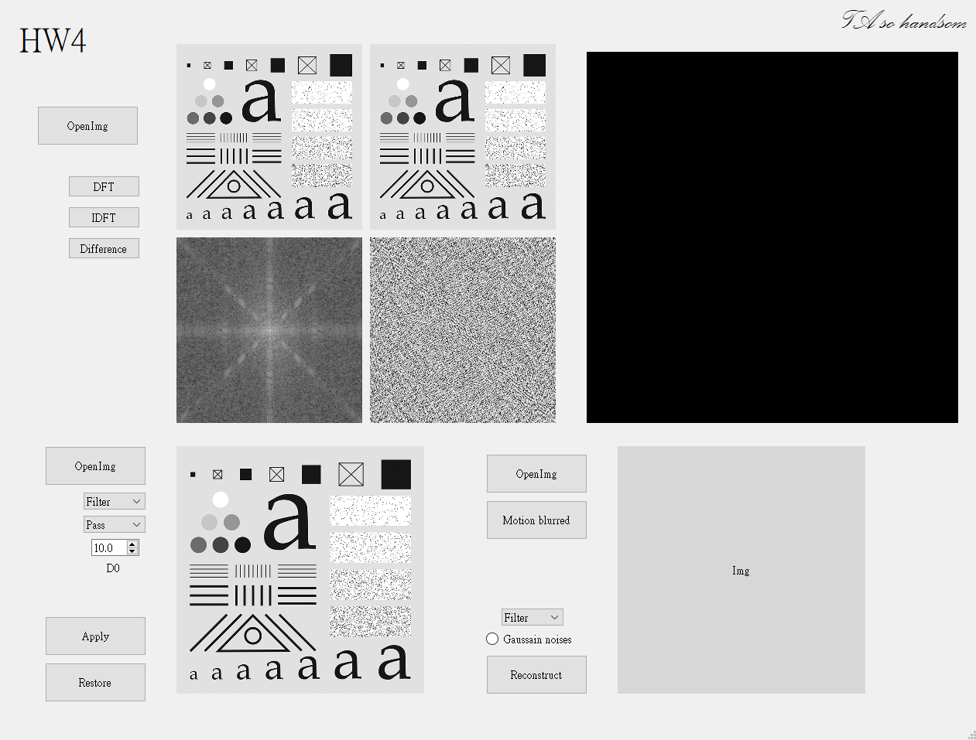

# Part 1

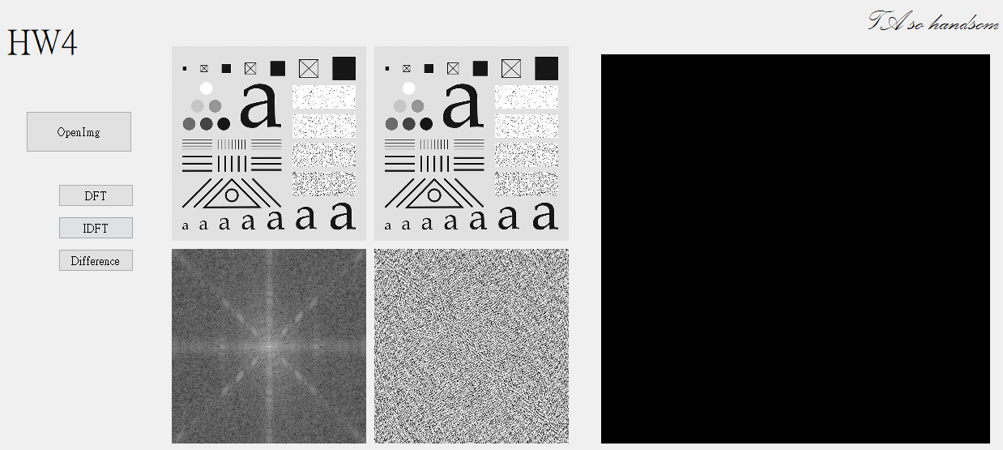

This is a demonstration of fast fourier transform. The upper left is original image; the bottom left is magnitude spectrum normalizing to (0,255) and shift the low frequency part to the center; the bottom right image is the phase angle spectrum; the upper right is inverse fast fourier transform image. When we press the “Difference” button, we can get the difference of the original image and the inverse fourier transform image by substracting the original one from the inverse fourier transform one. The result is a full 0 image, which indicates that the two image is exactly the same.

# Part 2

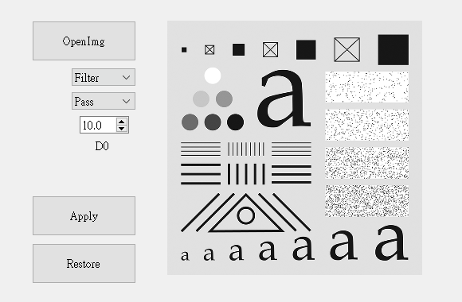

“Filter” is a comboBox, and we can choose filter type such as “Ideal”, “Butterworth”, “Gaussian” and “Homomorphic” from it. “Pass” is another comboBox and offers “High” and “Low” pass filter type. D0 is cutoff frequency and we can choose it from 10 to 100.

## Original Gaussian filter

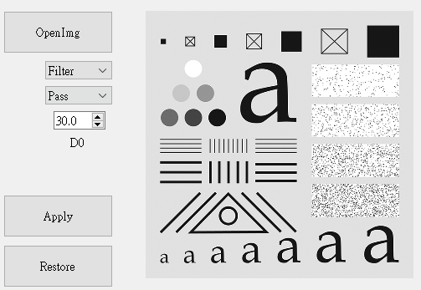 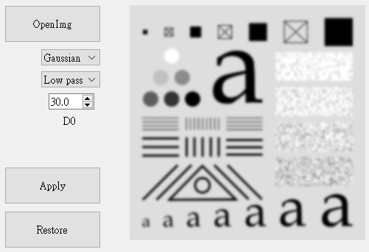

## Ideal filter Butterworth filter

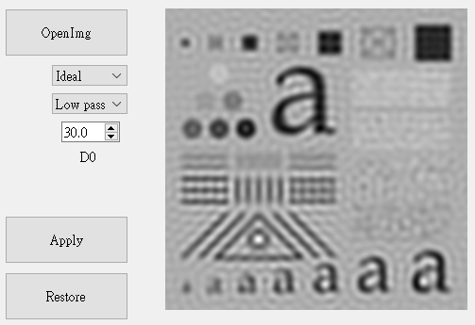 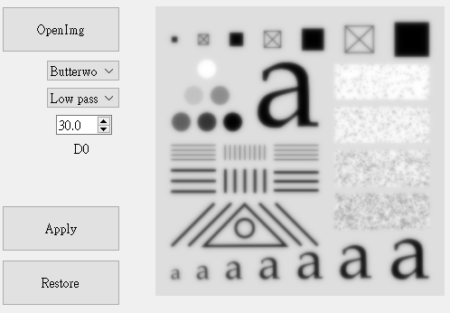

A comparison of three type of lowpass filter and original image with a cutoff frequency of 30 pixels. Apparently, there is a ringing effect when an image applied with an Ideal lowpass filter.

## D0 = 30 D0=60 D0=90

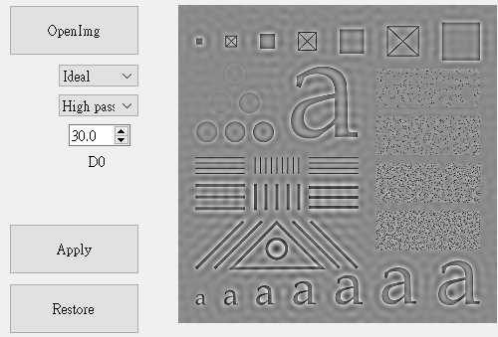 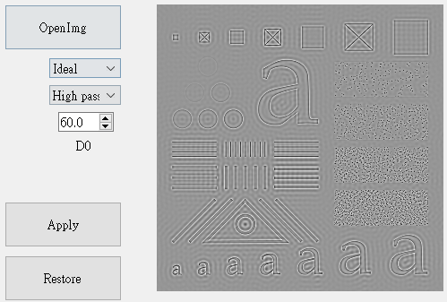 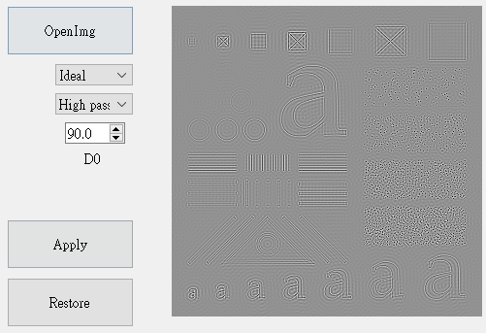

This is a comparison of three different cutoff frequency image applied with an Ideal highpass filter. With higher value of cutoff frequency(D0), the less informations in image are left, which makes sense because, with highpass filter, the higher D0 means the more is set to 0 in frequency domain.

# Part 3

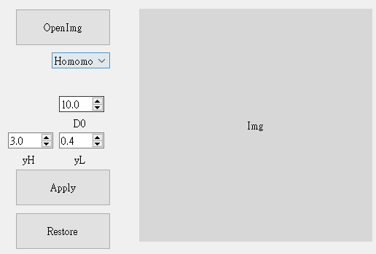

If we choose Homomorphic filter, the user interface becomes what the above shows.

We can dynamically adjust the yH and yL which is represented in the following homomorphic equation.



## yH > yL yH < yL

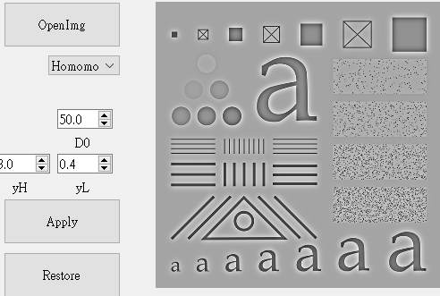 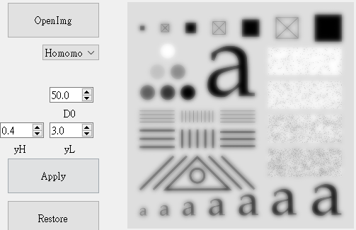

The result can be clearly explained with the following figure

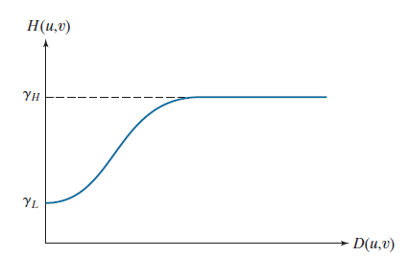

If yH > yL, the homomorphic acts like a highpass filter. Conversely, if yH < yL, the homomorphic filter is like a lowpassfilter.

# Part 4